**Agent Christine Installation Instructions:**

1. Navigate to the following GitHub repository URL:

[GitHub - microsoft/Agent-Christine: Build your own agent for Marketplace assistance](https://github.com/microsoft/Agent-Christine)

1. From the Agent Christine GitHub main page, locate the most recent agent packet by first selecting the file folder labeled “src”.

1. Locate Agent Christine from inside the SRC folder and select it.

1. Select the download button on the far right side of the screen. The file will be saved to your local downloads folder.

1. With the agent packet now downloaded, open a new tab in Microsoft Edge and navigate to “copilotstudio.microsoft.com”.

1. Sign into your copilot studio environment. Locate the “Agents” button in the left blade menu and select it.

1. From inside the newly opened “Agents” screen, select “Import Agent” from the upper left corner area of the screen.

1. A new tab will open displaying the Copilot Studio Environments workspace. Near the upper left corner of the screen, select the “Import solution” option.

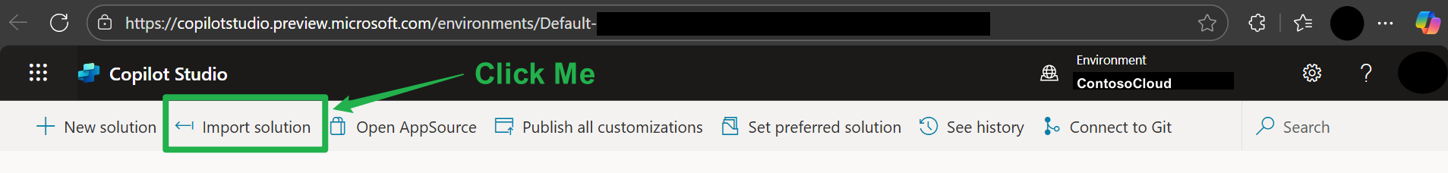

1. A new blade menu will open on the right side of the screen. Select the “Browse” option from in the menu, locate the agent packet, and select it to import into copilot studio. Then select “Next”.

|  |  |
| --- | --- |
|  |  |

*\*Tip: If you or someone else has already imported a previous version of an agent to Copilot studio and the modes do not match (managed vs. unmanaged) you will need to delete the previous version of the agent before you can import the new or latest version of the agent. Else you will receive an error message like as seen below.*



1. The agent packet will be parsed. Your credentials may also be checked. If there are required steps, they will be presented in the blade menu. If all check marks are green, proceed to select “Import”.

1. You will see a status message in the upper right area of the screen, indicating the agent is being imported. This process takes approx. 2-5 minutes.

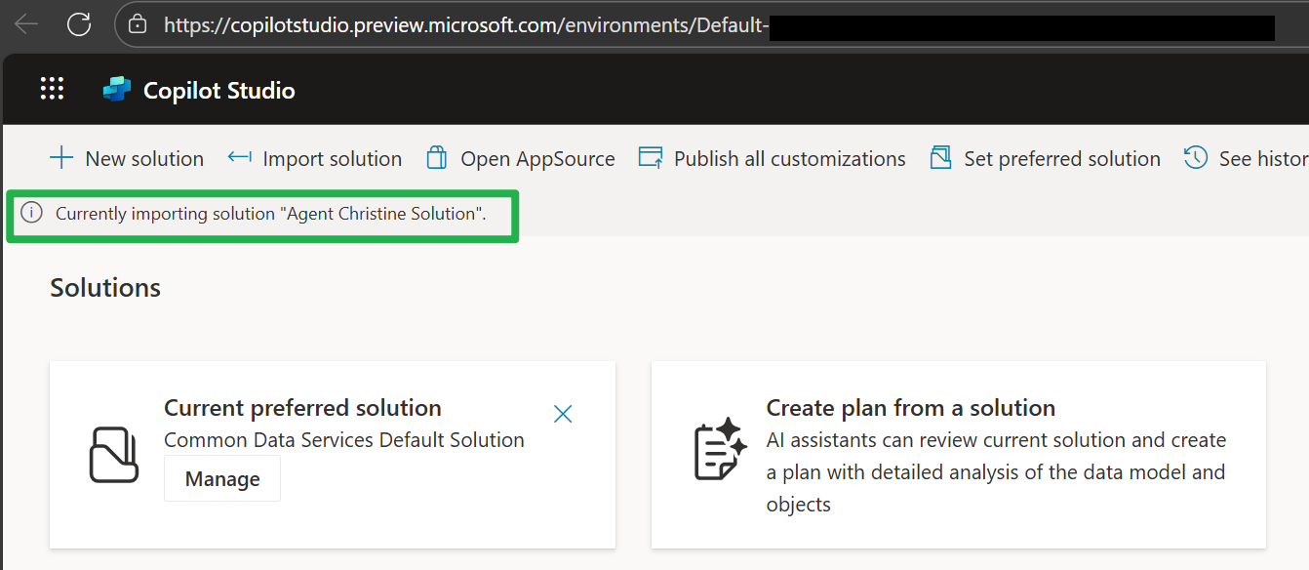

1. Upon successful completion you will see a green banner and success message indicating the agent import has completed. Navigate back to the copilotstudio home page (<https://copilotstudio.preview.microsoft.com/>)

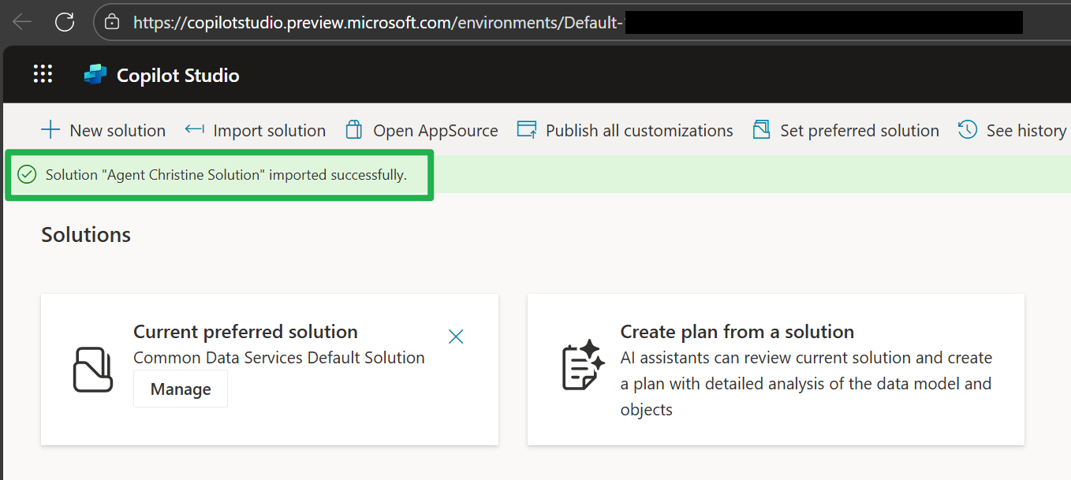

1. Under the agents section in the homepage you will now see “Agent Christine” in the agents list. Select the agent.

1. You will be taken to the interaction screen for the agent. You may now begin interacting with Agent Christine!

